Owosso

Whitmore Lake

Howell

Cohoctah

Byron

Durand

Oakley

Ashley

Ithaca

Middleton

Shepherd

Rosebush

Lake George

Marion

McBain

Grawn

Bates

Walton Jct.

Kalkaska

Elmira

Mancelona

Boyne Falls

Clare

Yuma

**Great Lakes Central Railroad**

**600 Oakwood Ave. Owosso, MI 48867**

**Phone: 989-725-6644**

**Fax: 989-723-8226**

**www.glcrailroad.com**

-----Great Lakes Central Railroad

-----Canadian National

-----CSX Transportation

-----Norfolk Southern

-----Shortline Partners

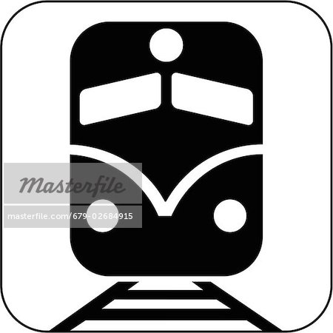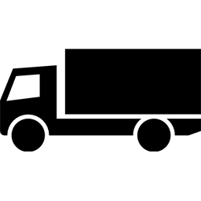

Transload Location









